**Installed Virtual box with Ubuntu**

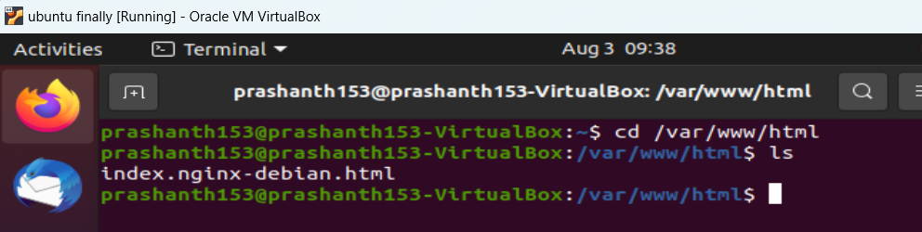

**Website is deplaying when I give the IFconfig and click on the IP**

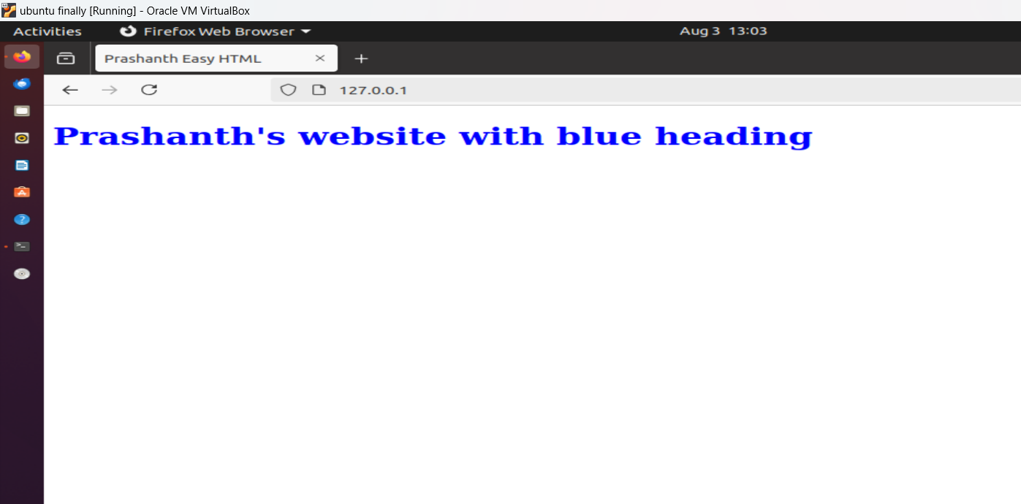

**NMAP output & open ports 80 and 631**

